Hours of Operation:
Tuesday & Thursday 5:00 P.M. - 8:30 P.M.
Saturday 10:00 A.M. – 1:30 P.M.
Schedule
Tournaments: February, May, August and November
Handicap Leagues: (Members only): Duration varies from 1 month to 3 months. Point system already determined as well for starting score.
Fees
Club Visitations: $5/Session-$25/Month-$250/Year
Private Lessons (with Head Coach): $50/hour for non-members-$40/hour for members / (Assistant Coach): $25/hour
For more information or questions, please visit our website:
www.elpasotabletennis.com
Or e-mail:
Club Director- Mark Nordby marknordby@yahoo.com
Club Owner- Michael Gopin
michaelelpasott@gmail.com

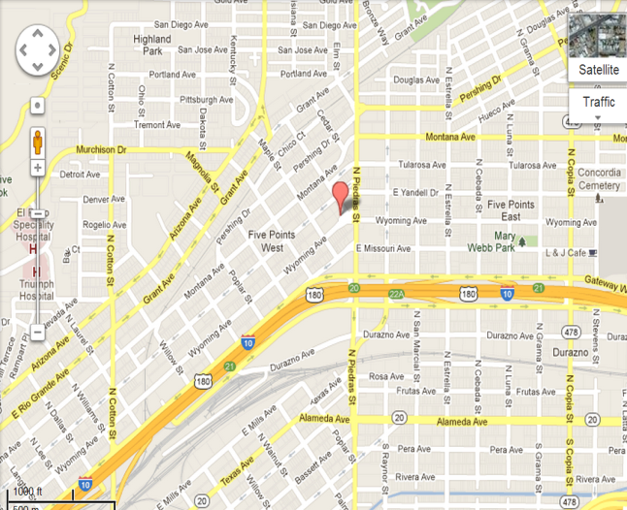
Directions:
From I-10 E.: Take exit 21 towards Piedras St. Merge into Gateway Blvd E. Turn left onto N. Piedras St. and another left on Wyoming Ave. Your destination will be on the right.
From I-10 W.: Take exit 21 towards Piedras St. Merge into Gateway W. Turn right onto N. Raynor St. then a take the second left onto Wyoming Ave. Your destination will be on the right.

Welcome

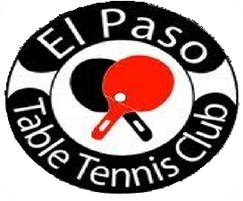
An affiliate of
About EPTTC
How it all began:
Since the 1930’s, many players have seen progress in the sport locally and around the world. It had a change of equipment during the 1950’s. Afterwards, the change in point system was made in the year 2001. Players had to play in gymnasiums, garages, and other places which had a table good enough to play. In the summer of 2009, the club “officially” opened its doors with a facility having incredible playing conditions, in which few U.S. clubs have.
Equipment and Testimonials:
The mat, Butterfly tables, balls, nets, scoopers and barriers have all been acquired by club owner Michael J. Gopin. “All I wanted to create is an environment that made players comfortable and create more popularity of the sport” M.J. Gopin said. Current club coach and player Mark A. Nordby has great insight of the sport. “I like to work with people that have that passion for the sport. They are the ones that inspire me to continue doing my job as Head Coach” said Coach M.A. Nordby. Danny Seemiller (‘04 & ’08 Men’s U.S. Olympic Coach) said “The El Paso Table Tennis Club is a first class organization. The club has excellent playing conditions and a full time national level coach. El Paso does table tennis the right way!”
Equipment
- Pre-Assemble Racquets
- Paddles
- Paddle Cases
- Balls (Gambler, Double Fish, DHS, and Butterfly)
- Side Tapes
- Rubbers (729, Butterfly, Gambler, Donic, DHS, and Dr. Neubaeur)
- Racquet Care
Health Benefits
Dr. Wendy Suzuki, professor of neuroscience and psychology at New York University, explained that table tennis has various health benefits. "In ping pong, we have enhanced motor functions, enhanced strategy functions and enhanced long-term memory functions,” she explained. She added that there are three major areas affected by this high-speed game. The fine motor control and exquisite hand-eye coordination involved with dodging and diving for the ball engages and enhances the primary motor cortex and cerebellum, areas responsible for arm and hand movement.
Photos
